# Router mode

1. Enable '>'

2. Privilege '#'

3. Global Config '(config)#'

**Enable -> ('en' / 'enable') -> Privilege -> ('config t' / 'config terminal') -> global config mode**

## Router to switch connection:

en

config t

interface 'wirename' [Example: gig0/0/0, fa0/0]

ip address 'gateway_address' 'subnet mask'

no shutdown

## Change Router name:

hostname 'name'

# 1. Telnet Connection

(global config mode)

enable secret 'password'

now, if we change mode from enable to privilege mode, we will need to give password.

## Telnet configuration (Router CLI):

line vty 0 5 [this means 0 - 5 or 6 users at a time can access the telnet]

login

password 'telnet_password' [give a password]

end

end [Telnet saved]

exit [return to enable mode]

## Now in any PC's command prompt:

telnet 'gateway address'

give telnet password

[Now you can access the router from PC, this is with the help of telnet]

[Anything you did in router cli, you can now do it from PC's command prompt]

# 2. Static Routing

## Router Configuration [Do this to each Router]:

enable

config t

hostname 'Router_name' [optional]

interface 'wirename'

ip address 'network host_address' 'subnet mask'

no shutdown

exit

## Static Routing [Do this for each route/ network in each router]:

ip route 'destination network_address' 'Subnet mask' 'Next hop_address'

'destination network_add' = each network which is not connected with the router

'next hop_add' = next router's entrance address for going to the destination address

# 3. DHCP (Dynamic Host Configuration Protocol)

automatically assigns IP address to the pcs

## Switch gateway config:

en / enable

config t / config terminal

hostname 'router_name'

int fa0/0

ip add 'gateway_add' 'subnet_mask'

no sh/ shutdown

## dhcp config:

ip dhcp pool 'poolname'

default-router 'gateway_address'

network 'corresponding network_address' 'subnet mask'

exit

# Connections

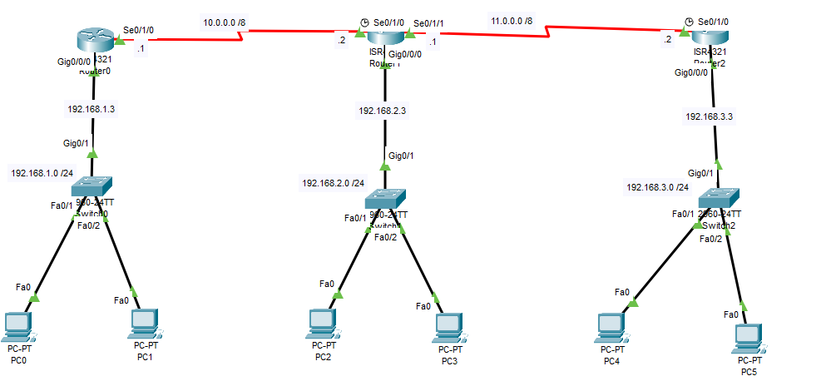

# Router to switch Configuration (DHCP)

## R1:

en

config t

hostname R1

int gig0/0/0

ip add 192.168.1.3 255.255.255.0

no sh

exit

ip dhcp pool p1

default-router 192.168.1.3

network 192.168.1.0 255.255.255.0

exit

## R2:

en

config t

hostname R2

int gig0/0/0

ip add 192.168.2.3 255.255.255.0

no sh

exit

ip dhcp pool p2

default-router 192.168.2.3

network 192.168.2.0 255.255.255.0

exit

## R3:

en

config t

hostname R3

int gig0/0/0

ip add 192.168.3.3 255.255.255.0

no sh

exit

ip dhcp pool p3

default-router 192.168.3.3

network 192.168.3.0 255.255.255.0

exit

# Router to Router Connection

## R1:

en

config t

int se0/1/0

ip add 10.0.0.1 255.0.0.0

no sh

exit

## R2:

en

config t

int se0/1/0

ip add 10.0.0.2 255.0.0.0

no sh

int se 0/1/1

ip add 11.0.0.1 255.0.0.0

no sh

exit

## R3:

en

config t

int se0/1/0

ip add 11.0.0.2 255.0.0.0

no sh

exit

# 4. Dynamic Routing

## RIP (Routing Information Protocol):

Router sends all the routing table.

### RIPV1: (not used anymore)

Router rip

network ‘network_address’

network ‘network_address’

### Ripv2: (do this in each router)

en

config t

Router rip

Version 2

no auto-summary

network ‘network_address’ [Connected networks with the router]

network ‘network_address’

# RIP

## R1:

router rip

ver 2

no auto-summary

network 192.168.1.0

network 10.0.0.0

## R2:

router rip

ver 2

no auto-summary

network 192.168.2.0

network 10.0.0.0

network 11.0.0.0

## R3:

router rip

ver 2

no auto-summary

network 192.168.3.0

network 11.0.0.0

## OSPF (Open Shortest Path First):

Router only sends updated network info.

router ospf 1

network ‘network_id’ ‘wildcard mask’ area 0 [Connected networks with the router]

network ‘network_id’ ‘wildcard mask’ area 0 [area needs to be same for all routers]

Wildcard mask: 255.255.255.255 – corresponding subnet mask

subnet mask = 255.255.255.0

wildcard mask = 0.0.0.255

# OSPF

## R1:

router ospf 1

network 192.168.1.0 0.0.0.255 area 0

network 10.0.0.0 0.255.255.255 area 0

## R2:

router ospf 2

network 192.168.2.0 0.0.0.255 area 0

network 10.0.0.0 0.255.255.255 area 0

network 11.0.0.0 0.255.255.255 area 0

## R3:

router ospf 3

network 192.168.3.0 0.0.0.255 area 0

network 11.0.0.0 0.255.255.255 area 0

# 5. Switch Port Security

uses MAC address (48 bit)

1. Protected: Does not give access
2. Restricted: 1 + Sends a message to the admin
3. Shutdown: 1 + Shuts down PC

## Commands:

config t

interface ‘wire_name’

switchport mode access

switchport port-security

switchport port-security mac-address sticky [dynamically accesses mac address]

switchport port-security maximum 1 [maximum no. of users]

switchport port-security violation ‘mode’ [protect/restrict/shutdown]

## In Switch CLI:

### Privilege mode

en

show port-security

show port-security interface fa0/1

show port-security address

### Global config mode

config t

interface fa0/1

switchport mode access

switchport port-security

switchport port-security mac-address sticky

switchport port-security maximum 1

switchport port-security violation shutdown

After that you must ping from one pc to another to activate port security. And wait patiently, it takes time.

# 6. DNS (Domain Name Server)

It converts domain name to corresponding IP address.

PC -> Switch -> Server

In Server's

* DNS Server option, give a server address. [192.168.0.1]
* Desktop option, type IP address same as server address. [192.168.0.1]
* Services -> DNS option, turn on DNS service, give name and corresponding network address. [‘www.learnnetworking.com’, 192.168.0.1] then click add.
* Services -> HTTP -> index.html, edit, whatever you want to see in your website.
* Now in each PC give IP address and DNS server.
* Now from PC’s web browser go to ‘www.learnnetworking.com’. You can also type ‘192.168.0.1’ and get the same website.